Chapter 8 Practice Problems key

- Identify the solute in each of the following solutions.

- 2 g of sugar and 100 mL of water
The solute is sugar.

- 60.0 mL of ethyl alcohol and 30.0 mL of methyl alcohol
The solute is methyl alcohol.

- 55.0 mL of water and 1.50 g of NaCl
The solute is NaCl.

- Air: 200 mL of O₂ and 800 mL of N₂
The solute is O₂.

- Indicate whether solutions of each of the following contain only ions, only molecules, or mostly molecules and a few ions:

- Na2SO4, a strong electrolyte
An aqueous solution of Na₂SO₄ contains only the ions Na⁺ and SO₄²⁻.
- CH₃OH, a nonelectrolyte
A nonelectrolyte such as CH3OH produces only molecules when it dissolves in water.

- At 20 °C, the solubility of KCl is 34 g/100 g of water. In the laboratory, a student mixes 75 g of KCl with 200. g of water at a temperature of 20 °C.

- How much of the KCl will dissolve?

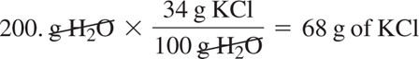

- Is the solution saturated or unsaturated?

Because 75 g of KCl exceeds the amount (68 g) that can dissolve in 200. g of water, the KCl solution is saturated.

- What is the mass, in grams, of any solid KCl on the bottom of the container?

If we add 75 g of KCl to 200. g of water and only 68 g of KCl can dissolve, there is 7 g (75 g – 68 g) of solid (undissolved) KCl on the bottom of the container.

- A solution is prepared by mixing 15.0 g of Na₂CO₃ and 235 g of H₂O. Calculate the mass percent (% m/m) of the solution.

Mass % (m/m) = 15.0 g Na₂CO₃ × 100% = 6.00% Na₂CO₃
250. g solution .

- Write two conversion factors for each solution.
  - 8.50% (m/m) NaOH

8.50 g NaOH and 100 g solution
100 g solution 8.50 g NaOH

  - 5.75% (v/v) ethanol

5.75 mL alcohol and 100 mL solution
100 mL solution 5.75 mL alcohol

  - 4.8% (m/v) HCl

4.8 g HCl and 100 mL HCl
100 mL solution 4.8 g HCl

- How many grams of NaOH are needed to prepare 75.0 g of 14.0% (m/m) NaOH solution?

75.0 g solution × 14.0 g NaOH = 10.5 g of NaOH
100 g solution

- What is the molarity of 0.500 L of NaOH solution if it contains 6.00 g of NaOH?

6.00 g NaOH × 1 mole NaOH = 0.150 mole of NaOH
40.0 g NaOH

M = moles solute = 0.150 mole NaOH = 0.300 M NaOH
L solution 0.500 L solution

- What is the molarity of 0.225 L of a KNO₃ solution containing 34.8 g of KNO₃?
34.8 g KNO₃ × 1 mole KNO₃ = 0.344 mole of KNO₃
101.1 g KNO₃

M = moles solute = 0.344 mole of KNO₃ = 1.53 M KNO₃
L solution 0.225 L solution

- How many milliliters of a 5.75% (v/v) ethanol solution can be prepared from 2.25 mL of ethanol?

2.25 mL ethanol × 100 mL solution = 39.1 mL of solution
5.75 mL ethanol

- How many grams of AlCl₃ are needed to prepare 125 mL of a 0.150 M solution?

0.125 L × 0.150 mole AlCl₃ × 133.5 g AlCl₃ = 2.50 g of AlCl₃
1 L 1 mole AlCl₃

- A topical antibiotic is 1.0% (m/v) Clindamycin. How many grams of Clindamycin are in 60. mL of the 1.0% (m/v) solution?
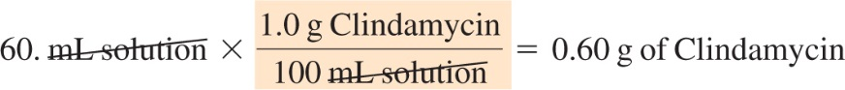
- How many liters of a 2.00 M NaCl solution are needed to provide 67.3 g of NaCl?
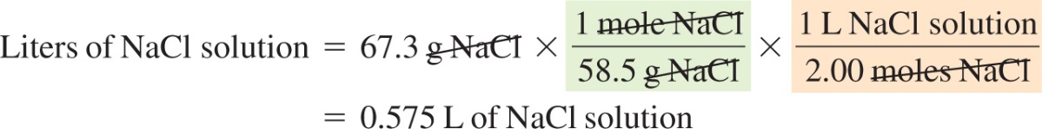
- What volume (mL) of a 2.5% (m/v) KOH solution can be prepared by diluting 50.0 mL of a 12% (m/v) KOH solution?

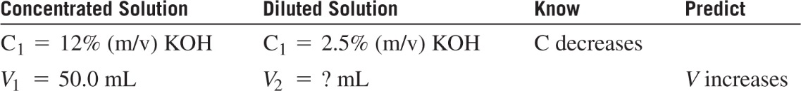
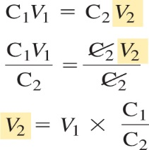
- What is the molarity of a solution prepared when 75.0 mL of a 4.00 M KCl solution is diluted to a volume of 500. mL?

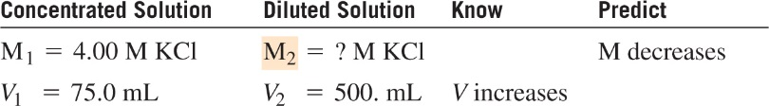

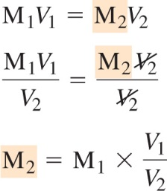
- The normal concentration of calcium in blood is 5.0 mEq/L. How many milligrams of calcium are in 1.0 L of blood?

